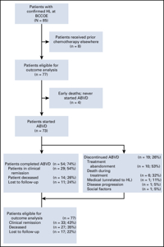
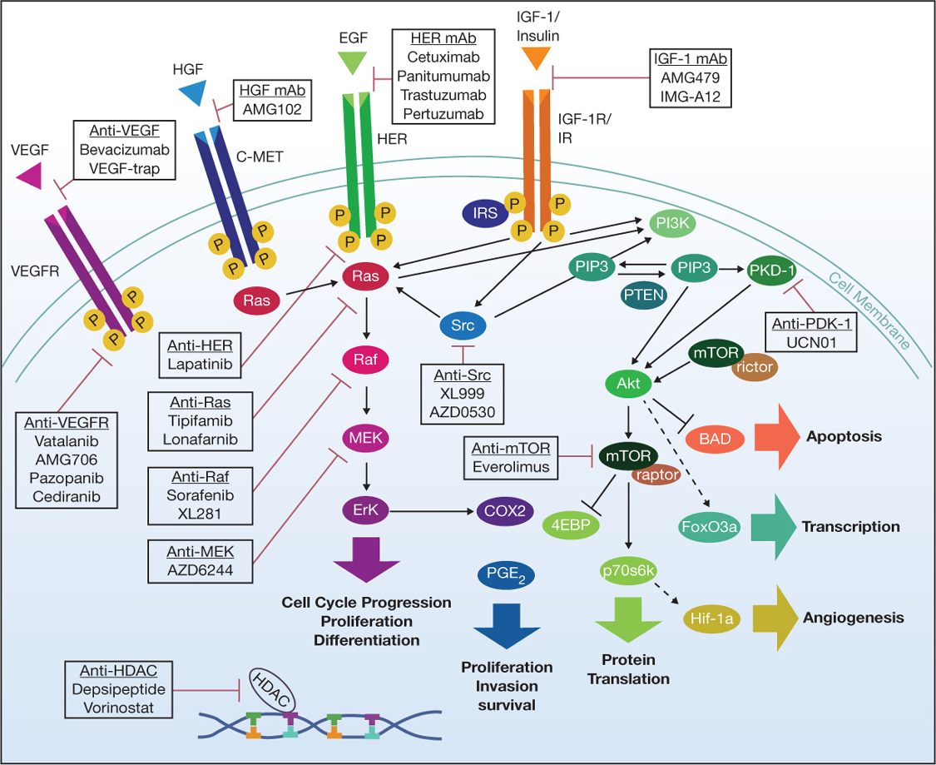
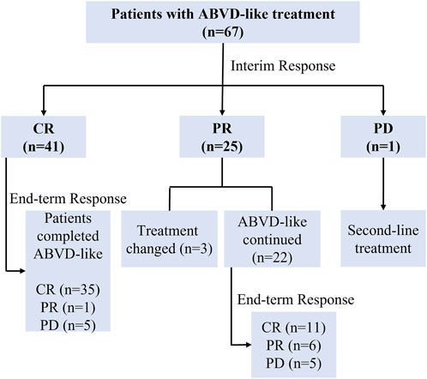
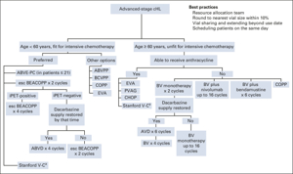
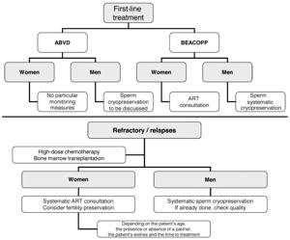
The ABVD cancer regimen is a standard chemotherapy protocol most commonly used as first-line treatment for Hodgkin lymphoma. ABVD is an acronym for the four drugs in the regimen:
- A: Adriamycin (doxorubicin) – an anthracycline antibiotic that damages DNA
- B: Bleomycin – an anti-tumor antibiotic that causes DNA strand breaks
- V: Vinblastine – a vinca alkaloid that inhibits cell division by disrupting microtubules
- D: Dacarbazine – an alkylating agent that methylates DNA and disrupts cell replication12356
Mechanism and Clinical Use:
- These drugs are combined because they attack cancer cells in complementary ways, maximizing tumor cell kill while minimizing overlapping toxicities35.
- ABVD is the most widely used regimen for both early and advanced-stage Hodgkin lymphoma due to its effectiveness and comparatively better side-effect profile than older protocols1456.
Administration:
- All four drugs are administered intravenously.
- Treatment occurs in cycles: each cycle lasts 28 days, with drugs typically given on day 1 and day 15.
- The duration of therapy and total number of cycles (usually 2-6) depend on disease stage and patient response125.
- Chemotherapy is typically outpatient but requires experienced medical supervision.
Notable Points:
- ABVD has largely replaced older regimens like MOPP due to superior efficacy and fewer long-term side effects such as infertility and secondary cancers4.
- Monitoring includes interim and post-treatment PET scans to evaluate response and guide therapy adjustments12.
- While ABVD remains standard, novel regimens may be used in some settings based on disease characteristics and patient factors6.
Key Cautions:
- ABVD drugs, especially doxorubicin and bleomycin, have notable risks including heart and lung toxicity, and require ongoing monitoring during treatment46.
- Administration should only be by clinicians experienced with chemotherapy due to risks such as extravasation and myelosuppression12.
ABVD remains an essential and effective standard regimen in the treatment of Hodgkin lymphoma.
- https://en.wikipedia.org/wiki/ABVD
- https://www.cancerresearchuk.org/about-cancer/treatment/drugs/abvd
- https://www.cancer.gov/about-cancer/treatment/drugs/abvd
- https://www.eviq.org.au/haematology-and-bmt/lymphoma/hodgkin-lymphoma/56-advanced-stage-abvd-doxorubicin-bleomycin-vinb
- https://www.drugs.com/medical-answers/what-abvd-chemo-regimen-how-used-lymphoma-3579886/
- https://www.patientpower.info/hodgkin-lymphoma/abvd-chemotherapy
- https://pmc.ncbi.nlm.nih.gov/articles/PMC7392734/
- https://www.sciencedirect.com/topics/neuroscience/abvd
- https://www.chemoexperts.com/abvd.html
- https://www.eviq.org.au/haematology-and-bmt/lymphoma/hodgkin-lymphoma/57-early-stage-abvd-doxorubicin-bleomycin-vinblas

